Steps to be followed to run the application.

Few software needs to be installed:

1.Python 27

2.boto-2.16.0

3.certifi-0.0.8

4.Configure CGI server

5.pycurl-7.19.02

Steps to configure:

Python comes with a mini-webserver in the CGIHttpServer module.

Here's how you can set it up from the command prompt:

1. Create a home directory for your server.

md \myserver

2. Make a cgi-bin subdirectory off the home directory.

cd \myserver

md cgi-bin

3. Copy the file CGIHttpServer.py to the home directory.

cd \myserver

copy \python27\Lib\CGIHttpServer.py

4. Put our cgi scripts (GetData.py,SendData.py and VersionData.py) in the cgi-bin directory.And the Html files(Home.html, InputPage.html, RestorePage.html,VersionPage.html) and css folders and images folder in myserver directory.

5. Change to the home directory and run CGIHttpServer.py

Pointing your browser at http://localhost:8000/Home.html will now execute the Project.

Note: The S3 bucket needs to be public for the tool to access.

On the Home Page You will see 3 buttons.

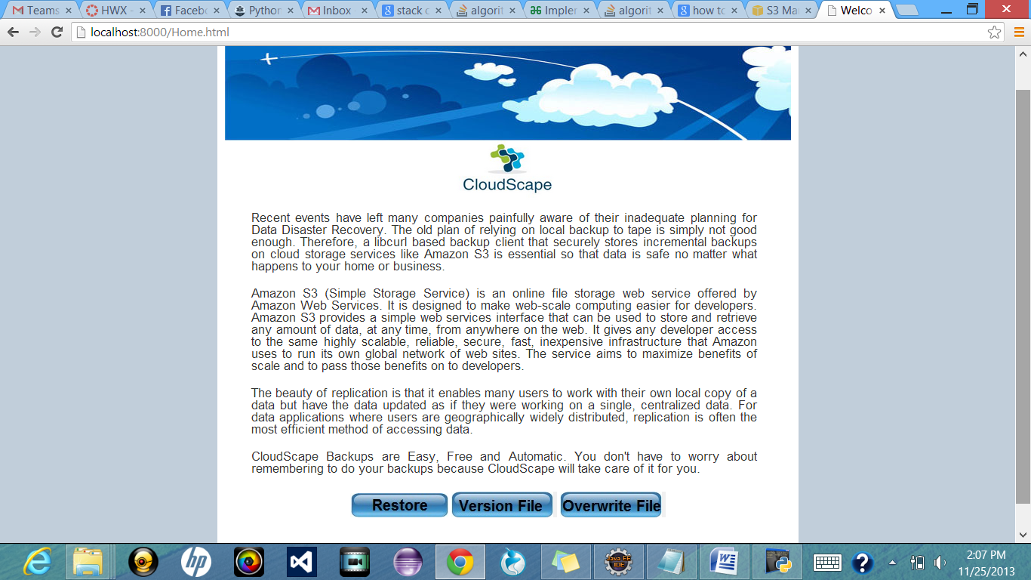

1. Click on Version File if you want to create different versions of your file each time you modify it.

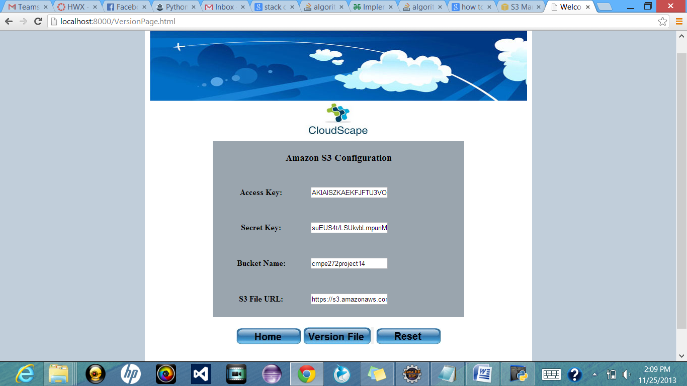

2. Enter the inputs Access Key, Secret Key, Bucket Name and S3 File URL(**till the folder path**) and click on Version File.

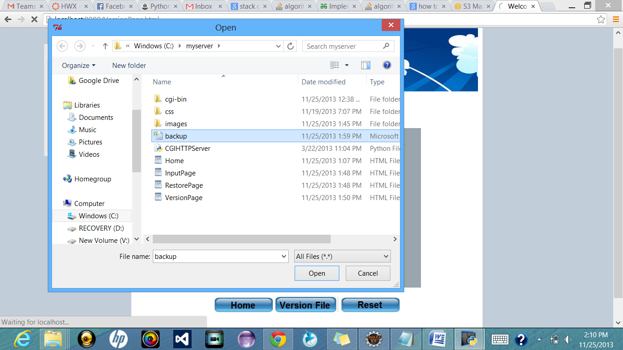

3. Select the file you want to back up from the pop up window. Open the file make changes and save it. First version of your back up will be created.

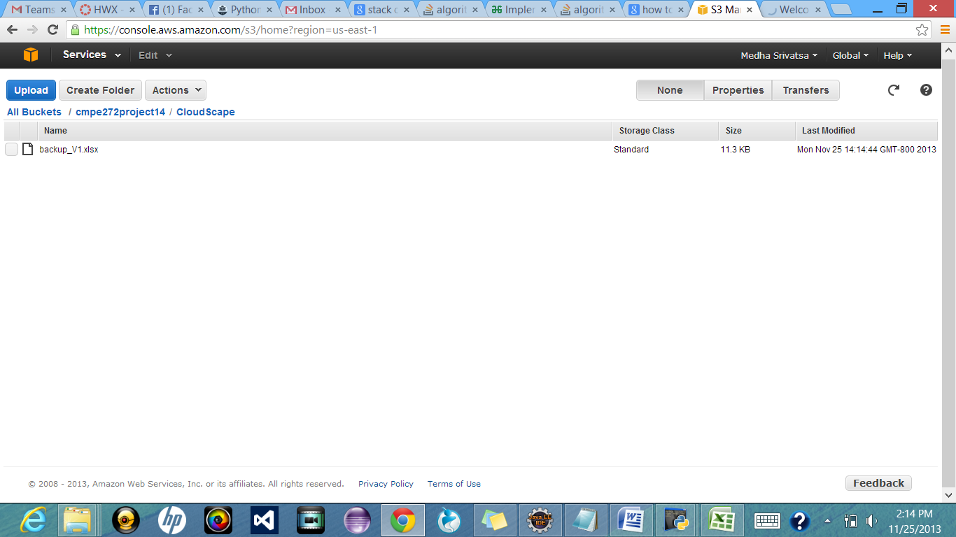

4. Close the window to exit. Each time you modify your file in Local and save , new versions of your file will be created. Stop the server to stop backing up the data.

Next Flow:

In case you want to overwrite your files and don't want to create different versions, Start the server again and run http://localhost:8000/Home.html.

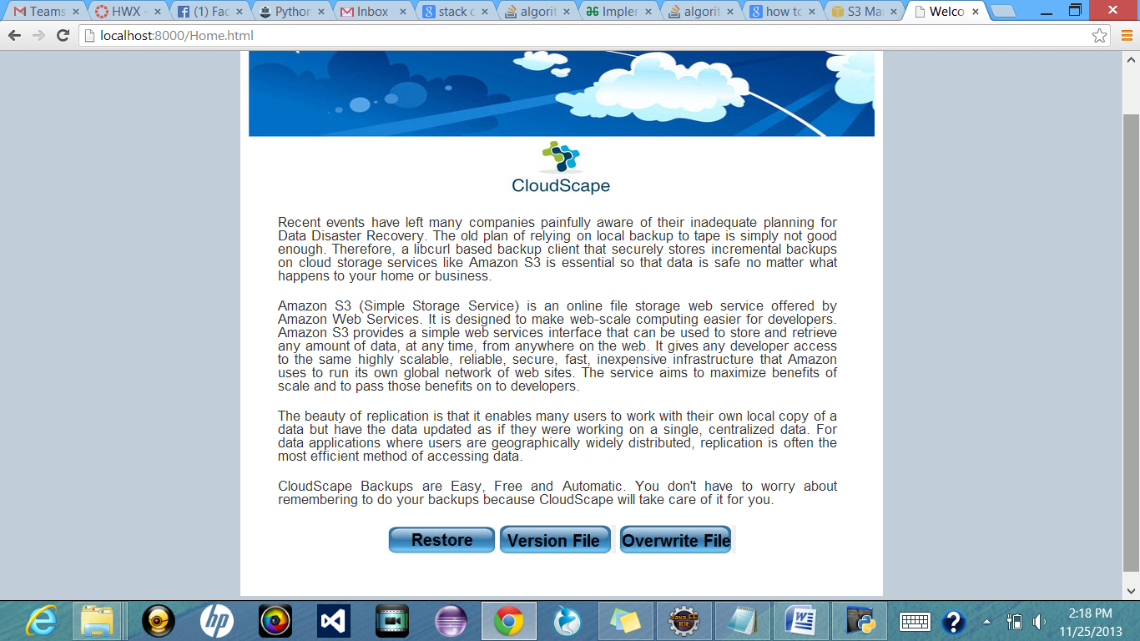

1. Click on Overwrite File.

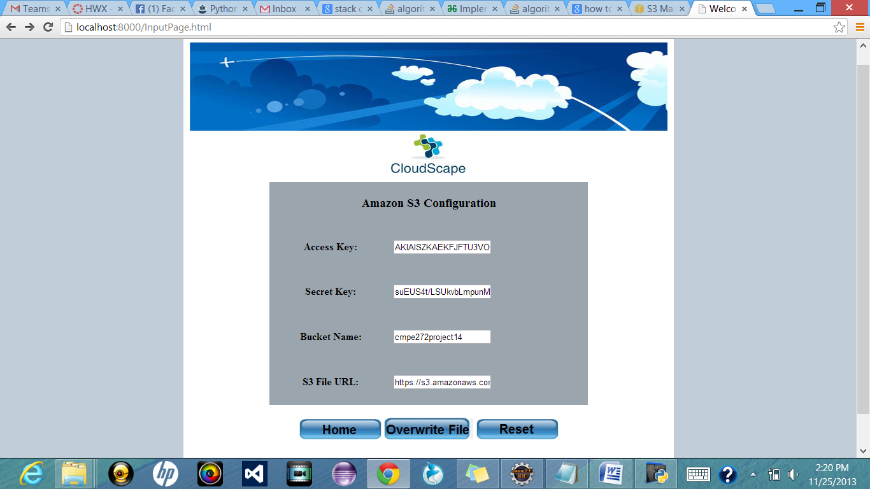

2. Enter all the details. This time File URL should be complete till the file name.Eg: https://s3.amazonaws.com/cmpe272project14/CloudScape/DocumentName.xlsx. Open the document and make changes and save the file. The file will be uploaded. Each time you modify the file the file will be overwritten in S3.

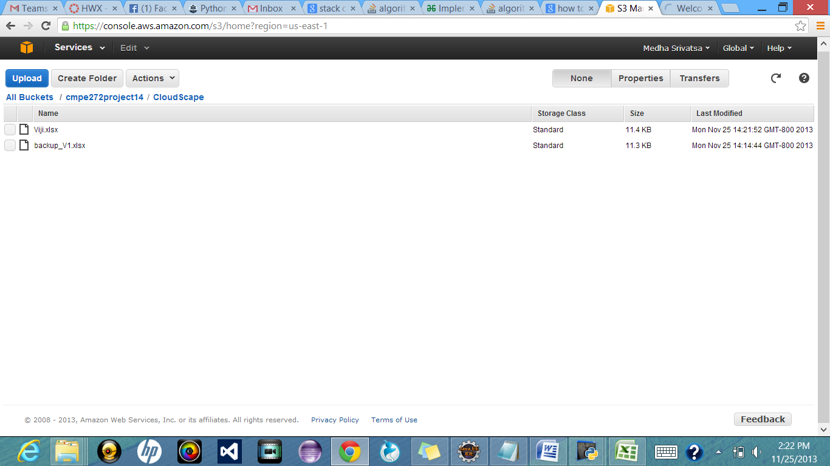

To Restore your file from S3 Click on Restore and follow the steps. Your file will be restored.